## **Summary:**

1. Auquan and NotreDame-mobility are good to go; NotreDame-mobility might need further clearification
2. MIT and LSHTM might work if we contact the developers
3. ICL and JHU each has some strange issues
4. Need to use Mac/Linux to test out CAN and UMass-MB

## **Auquan:**

### **Info Page:**

I was able to completely follow through their code and reproduce their results based on what they had on the website. Although we had some slight differences, that’s due to the date of data retrieval. <https://www.kaggle.com/davidadavid/how-we-built-a-covid-19-model-used-by-the-cdc/output>

Although they only talked about national level forecast on the webpage, they directly used JHU CSSE data from CSSE’s github repo without much modification. I think we can

1. Use files in CSSE’s repo for US state data to run the code, which should be fine because the formatting is similar
2. Alter the data so that we can incorporate different proportions of training and assessment data

Some things to note:

They calculated some parameters “Confirmed Case Fatality Rate (cCFR)” and “Infection Fatality Rate (IFR)” based on China and Korean data. We might need to take a further look at it.

### **Code:**

Code is in COVID-Projections/Test_Auquan_raw.ipynb

## **NotreDame-mobility**

### **Info Page:**

<https://github.com/TAlexPerkins/covid19_NDmobility_forecasting>

Info page didn’t contain any instruction.

1. We need to guess out the command line argument for running “script_forecast_simple.R”
2. I guess it is a state code (not fips, just simply based on alphabetical order) plus some numbers indicating different types of mobility. But I tried some combinations and didn’t see the differences.
3. It would run for around 30 minutes.
4. The out put contains some prediction matrix in a .RData file, but the naming of variables are very confusing so I couldn’t understand a lot about that. But overall I looked at the load data proportion and guess it would allow us to modify some of the training data start and end date and produce the result.

## **JHU:**

### **Info Page:**

<https://github.com/HopkinsIDD/COVIDScenarioPipeline> This is the home page of JHU model repo

I tried running the pipeline using instruction from this wiki: <https://github.com/HopkinsIDD/COVID19_Minimal/wiki/Getting-Started> which was listed in the README in home page.

### **Steps That I went through:**

1. The first step “Checkout projects from GitHub” was successful, but I couldn’t run the **Docker Image**, because it is not compatible with my windows version. This might be a reason that lead to the following problems.
2. I spent quite a while installing all the packages with COVIDSenarioPipeline/local_install.R and COVIDSenarioPipeline/packages.R
3. Then I ran this command, which looks fine.

Rscript COVIDScenarioPipeline/R/scripts/build_US_setup.R -c config.yml -p COVIDScenarioPipeline -w TRUE

1. In the third step, “Get shapefile data” I couldn’t run the command:

config <- covidcommon::load_config("config.yml")

tidycensus::census_api_key(key = config$importation$census_api_key)

covidImportation::get_county_pops(c('HI'), 'HI')

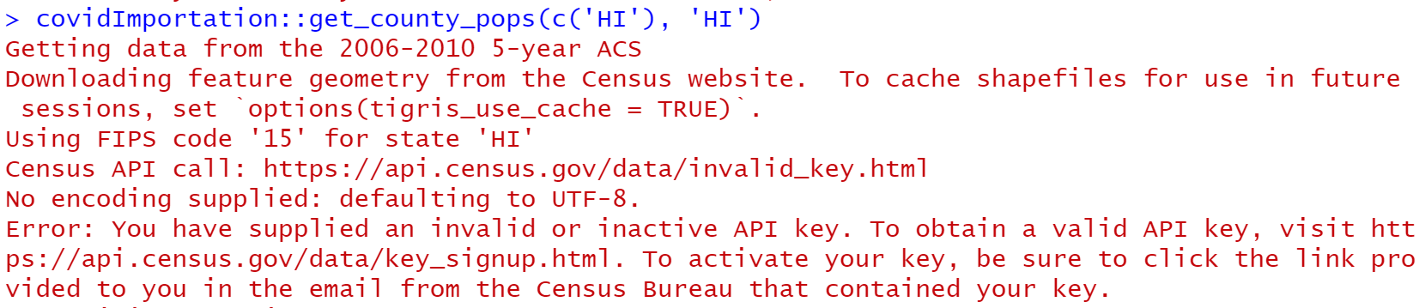

Looks like an API key problem but 1) obtaining a new API key needs an application and 2) this is a packaged function so I don’t know how I can alter it even if I get a new key.

## **ICL:**

### **Info Page:**

<https://github.com/mrc-ide/covid19-forecasts-orderly> This is the home page.

I followed the README in this page. This project uses a packaged called “orderly” which I think is pretty nice on enhancing reproducibility of code. However I still failed :(

### **Steps That I went through:**

1. First need to install orderly: install.packages("orderly")
2. The first step works after I added line 7 in the file prepare_ecdc_data.R

a <- orderly::orderly_run("prepare_ecdc_data")

orderly::orderly_commit(a)

1. I got stuck in the second step: process_individual_models

a <- orderly::orderly_run("process_individual_models", parameter =

list(week_ending = "2020-05-10"))

orderly::orderly_commit(a)

I looked at the description and looks like (since this is an ensemble model) there is a manual step of collecting different model out put from teams (from Drobox, for instance), which we have no access to, so we couldn’t run it.

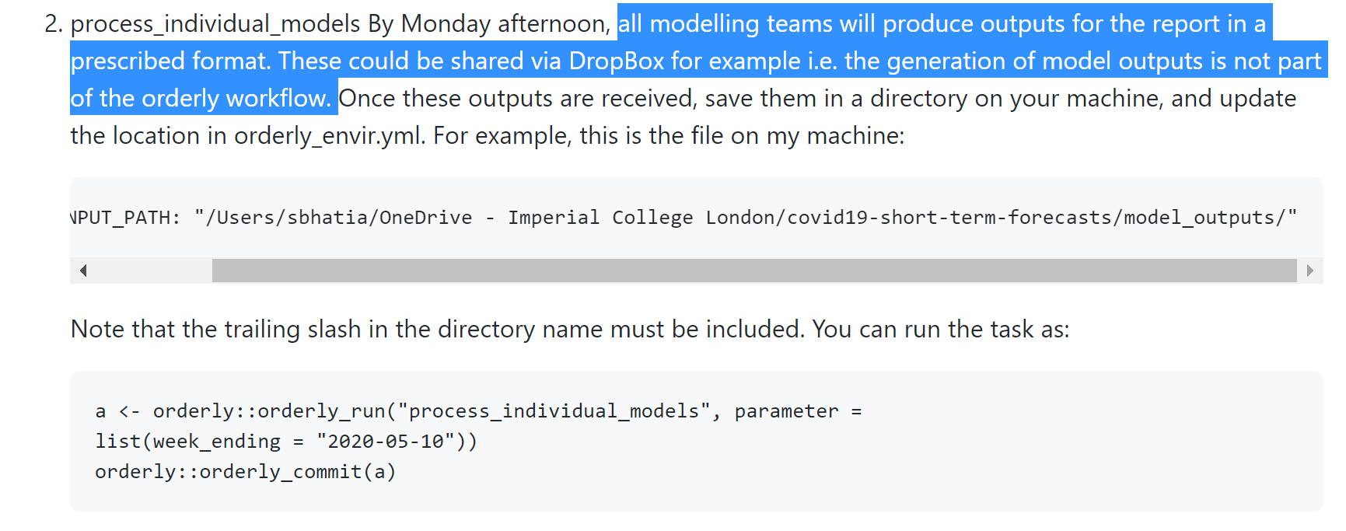

## **MIT**

### **Info Page:**

I tried to follow step in this README (although they didn’t actually say much about the procedure) <https://github.com/COVIDAnalytics/DELPHI>

The folder is almost 300 MB so I will not upload it to Dropbox, you can clone it from the github page

### **Steps That I went through:**

1. Alter the path configuration in config.yml
2. Run “DELPHI_model.py”

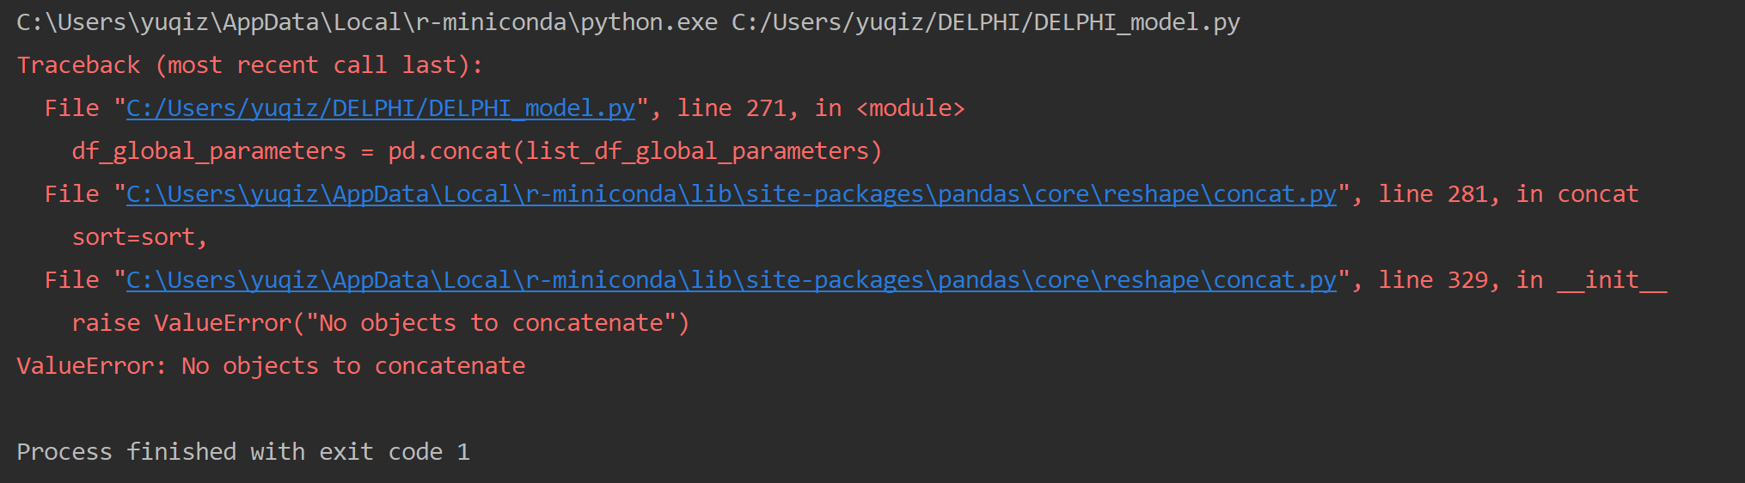

I think we are missing some data folder. In the config page I can’t find some data pages.

## **LSHTM**

<https://github.com/epiforecasts/covid-us-forecasts>

The folder is like 4.4G so I am not going to upload it.

Just run “run_everything.R”

It kept running for more than 1 hr but didn’t change with the line running the pipeline for “2020-06-30”.

## **CAN**

### **Info Page:**

<https://github.com/covid-projections/covid-data-model>

I don’t quite understand what they are doing based on the README. It involves using their API to run and download results. I am not quite familiar with bash and shell script, especially because I am using windows, so we might need further look at that.

Plus if you click “Check It Out in Jupyter” it would give an error:

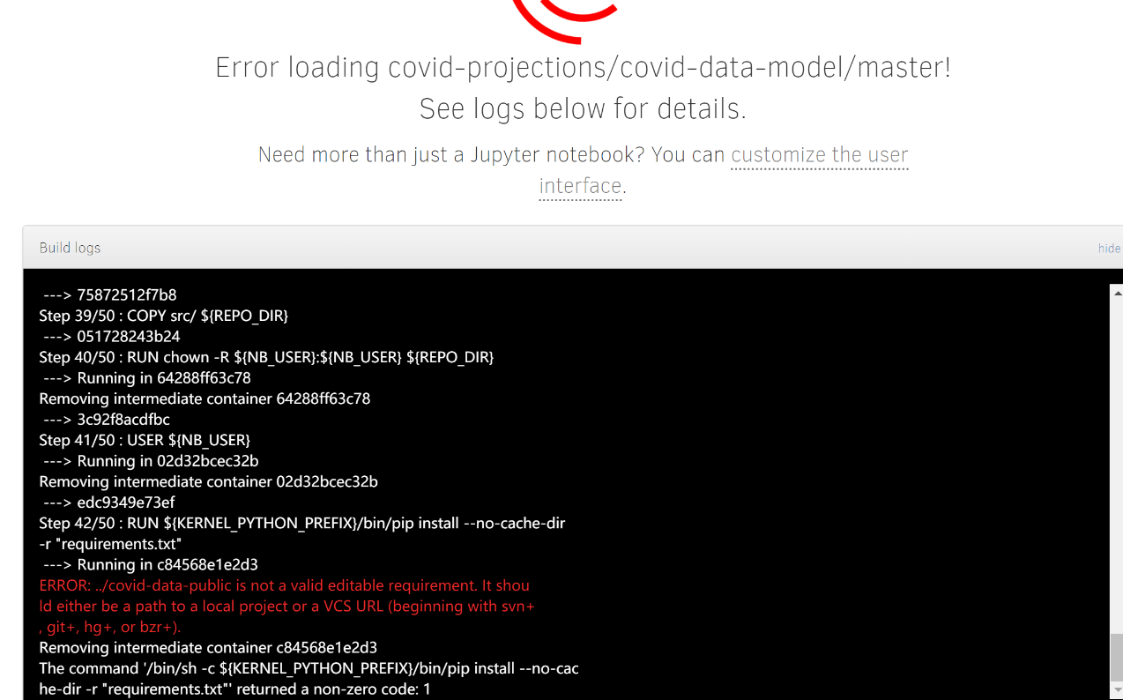

## **UMass-MB**

Tried running their installation command but failed because there is a package that doesn’t support windows…

Yuqi

07/02/2020